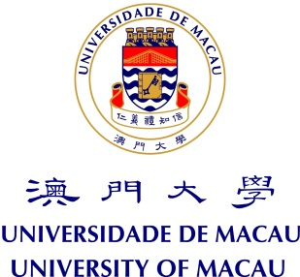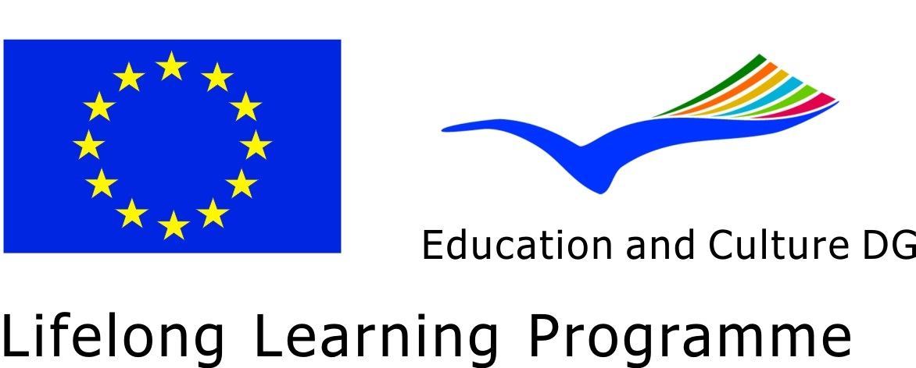

FACULTY OF LAW

MASTER OF LAW SEMINAR SERIES - 2012-2013

Jean Monnet Seminar

This Seminar is offered as part of the Master of Law Program in
European Union Law, International Law and Comparative Law
and the Jean Monnet Module at the University of Macau

Title: Public Finance and Financial Crisis

Prof. Guilherme d’ Oliveira Martins

Professor, Faculty of Law, University of Lisbon, Portugal

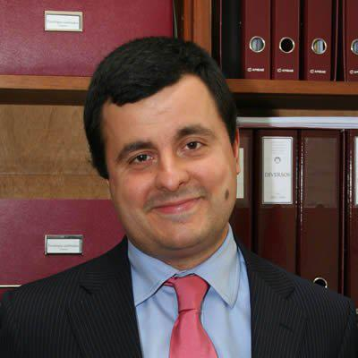

- BIO-NOTE:
Guilherme Waldemar d’Oliveira Martins obtained a PhD in Law, specialty in Public Finance, from the Faculty of Law of Law of the University of Lisbon. He is at present carrying out duties as a Auxiliary Teacher at the Faculty of Law of the University of Lisbon, where he works in the Legal and Economic Sciences area. He was a teacher at the Military Academy and the Faculty of Economics and Management, of the Catholic University of Portugal. He is a lawyer registered within the Municipal Council of Lisbon. He is a member of the board of Instituto de Direito Económico, Financeiro e Fiscal (IDEFF), Executive Secretary for the Advanced Postgraduate Course in Public Sector Finance and Management and organises the Tax Benefits module in the Postgraduate Course in Tax Law at IDEFF. He joined the Tax Benefits Re-evaluation Committee, following his appointment by Order of the Minister of State for Finance, in May 2005, and has been a legal adviser to the Office of the Secretary of State for Fiscal Affairs since 2005 (the 17th and 18th Constitutional Governments). He was the Chairperson of the Interministerial Council for the Coordination of Tax Incentives for Investment (2010 - 2012). He is author of several books and articles on Public Finance and Tax Law.

- ABSTRACT:
The global financial crisis has changed the classic view of public finance. Changed the principles, the rules and the way the States establish relations. This conference aims to provide a comprehensive overview of these changes and provide clues to explore the new concept of public financial decision in a context of global environment and full respect for human development.

