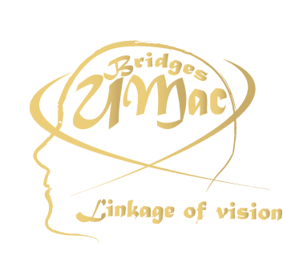 |  | 

UMAC BRIDGES 2007®
ALL RIGHTS RESERVED
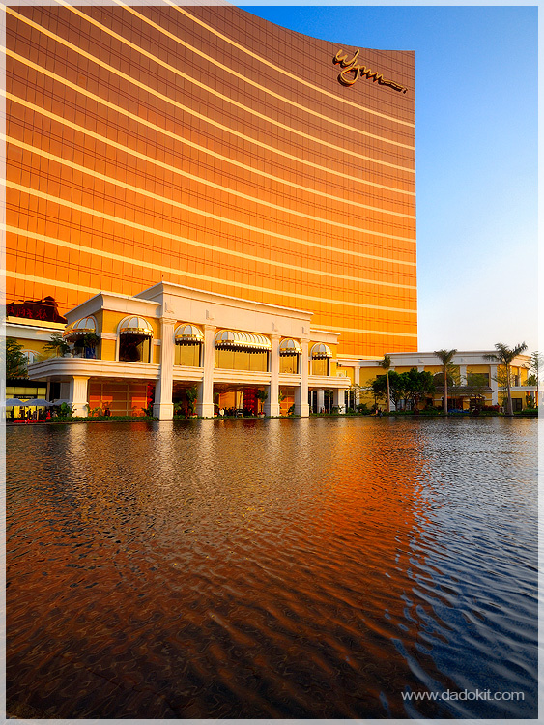
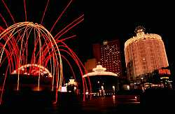
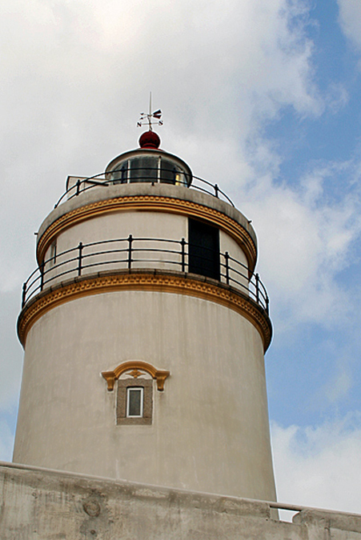
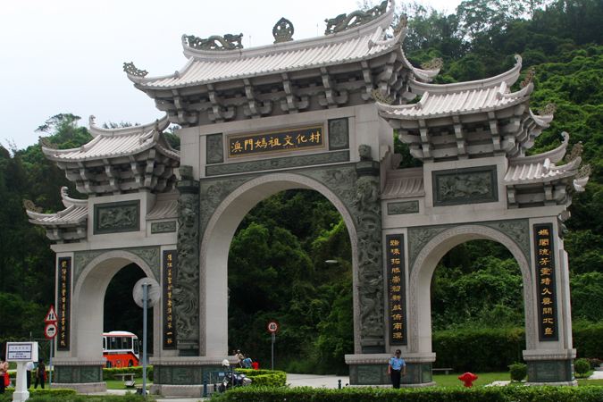
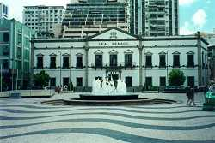
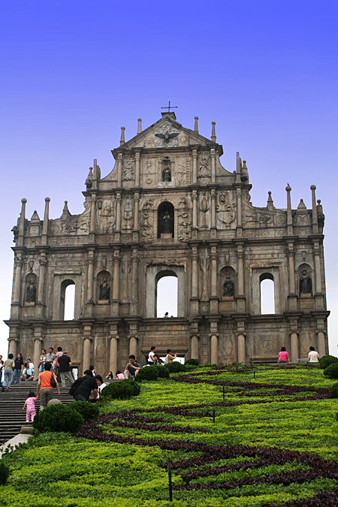

UMAC BRIDGES
“黃金時代最具代表性的建築物”攝影比賽章程
- 目的：令其他學院的學生可參與本雜誌的制作。透過是次攝影比賽，可令參實者更了解本澳的事物。

(二) 參賽辦法：
內容：凡以2006-2007年澳門具有代表性的建築物為主題的作品均可參加。
參賽資格：所有對攝影有興趣的學生均可參加。
相片要求：菲林相機或數碼相機作品，黑白及彩色均可。
規格：作品大小為4R(400萬像或以上)，必須用黑框裝裱。
參賽作品數量：每位參賽者只限最多兩項作品
參賽作品識別：參賽者須於作品背面寫上編號、學生編號、作品題名、作者姓名、通訊地址及聯絡電話。

(三) 截件日期：2007年4月23日 (星期一)

(四) 收件地點：何賢會議中心門口

(五) 評選委員：由主辦單位邀請有關專業人士擔任。
(六) 結果公佈：2007年5月UMAC BRIDGES 發佈日。得獎者將獲得專函及電話通知。
(七) 獎項：
冠軍：獎狀及獎金澳門幣四百元正
亞軍：獎狀及獎金澳門幣三百元正
季軍：獎狀及獎金澳門幣二百元正
最具創意大獎：獎狀及獎金澳門幣一百元正
(所有得獎作品將會印刷在UMAC BRIDGES 內)
(八)查詢：邵小組/譚小姐/簡小姐
電話: 66330046 / 66510606 / 66625490
電子郵箱：umacbridges@gmail.com

*章程如未盡善之處，主辦單位有權修改*

Regulations for the UMAC BRIGES
“Golden Era – The Most Representative Building” Photo Competition
1. Objectives: Our aim is to encourage students from other faculties to participate in the production of our UMAC BRIDGES. Through this competition, participants could have better understanding of Macau.
2. Requirements:
Content: Any works capturing Macau’s most representative buildings will be accepted.
Eligible Participants: All students who are interested are welcome
Photo Requirements: All kinds of works, black & white or color, taken by film camera or digital camera.
Photo Size: 4R (4.0 mega pixels or above). Each photo must be framed on a black cardboard paper
Maximum submission per person: Maximum to 2 photos for each participant.
Participant Identification: A participant must provide the photo number, student number and topic of his/her work, his/her name, address and contact number(s) on the reverse.

3. Submission Deadline: April 23rd 2007 (Monday)
4. Receiving Address: In front of Ho Yin Convention Center
5. Judging Panel: The panel members will be experts invited by the Organizer.
6. Result Announcement: May 2007, The publication day of UMAC BRIDGES. All winners will be informed individually.

7. Prizes:
Champion: a certificate and MOP400
1st Runner-up: a certificate and MOP300
2nd Runner-up: a certificate and MOP200
The Best Creative Champion: a certificate and MOP100
(The photos of all winners will be published in the UMAC BRIDGES)

8. Enquiry: Mina Siew / Sharon Tam / Rossetti Kan
Tel.: 66330046 / 66510606 / 66625490
E-mail: umacbridges@gmail.com

